**Practical-3**

* **AIM:-** Perform the following tasks using JavaScript

1. Print prime Numbers up to the given value in the input box.

**Source Code:-**

    const prompt=require('prompt-sync')();

    function prime(n1){

        for(let i=2 ; i<=n1/2 ; i++){

            if(n1 % i == 0){

                return false;

            }

        }

        return true;

    }

    let n1 = prompt("Enter your first number:");

    let n2 = prompt("Enter your second number:");

    for(let i=n1;i<=n2;i++){

        if(prime(i)){

            console.log(i+" ");

        }

    }

**Output:-**

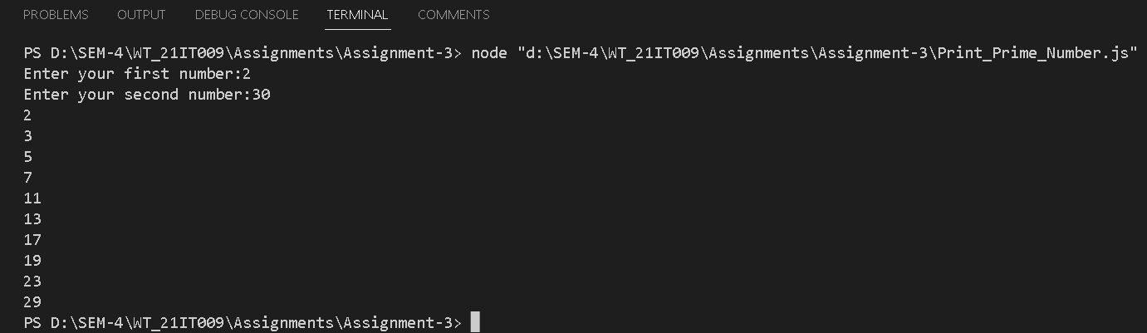

**Conclusion:-**

From this practical, I learned How to take inputs in JavaScript and how to declare the function in JavaScript and how to display the output on the console.

1. Write Script to reverse the given input string.

**Source Code:-**

const prompt=require('prompt-sync')();

let str=prompt('Enter a string: ');

let str2="";

for(let i=str.length-1;i>=0;i--){

    str2+=str.charAt(i);

}

console.log(str2);

**Output:-**

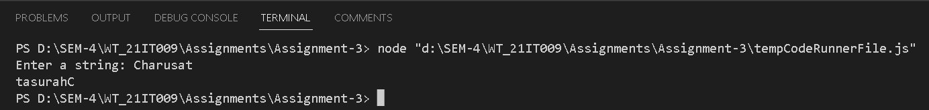

**Conclusion:-**

From this practical, I learned about how to reverse the string using loop in JS.

1. Create Dynamic Multiplication Table using inputs.

**Source Code:**-

const prompt=require('prompt-sync')();

let n = prompt("Enter the number: ");

let m = prompt("Enter the range: ");

if(n==0){

    console.log("Cannnot make the multiplication");

}else{

    for(let i=1;i<=m;i++){

        // console.log("The multiplication of "+ n +" with " + i + " is " + n*i);

        console.log(n + " * " + i + " = " + (n * i));

    }

}

**Output:-**

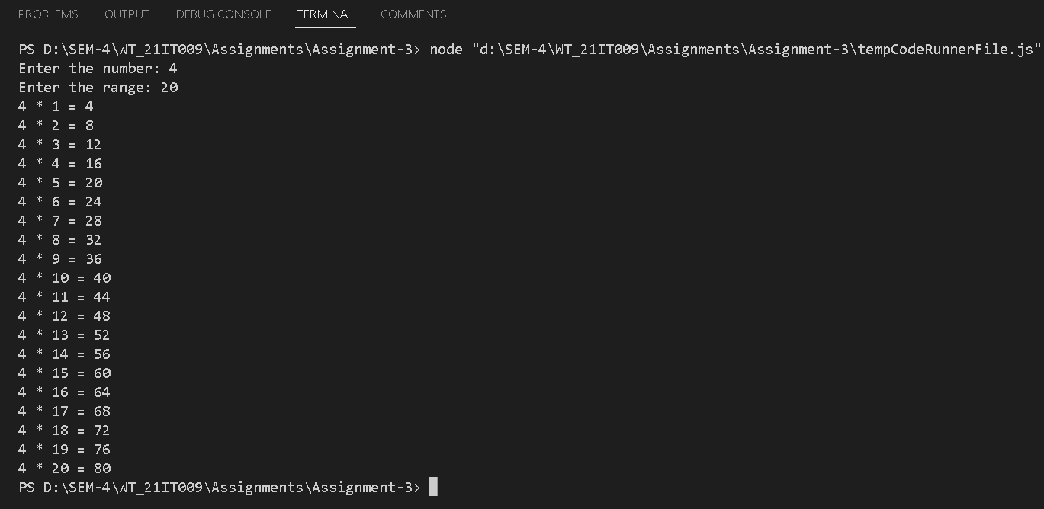

**Conclusion:-**

From this practical, I learned how to display the table format in JS.

1. Find the Age from input date.(Ex. 17 Yrs, 3 Monts,13 Days).

**Source Code:-**

const prompt=require('prompt-sync')();

let n1 = Number(prompt("Enter your birthdate: ")); // please input the date in ddmmyyyy format otherwise it will

let n = new Date();

let str="";

str += n.getDate();

str += n.getMonth()+1;

str += n.getFullYear();

let num = Number(str);

if(n<=0){

    console.log("Invalid date");

}else{

    console.log(n1 - num)

}

**Conclusion:-**

From this practical, I learned about date objects in JS and how to take inputs in JS and create the object in JS, and how the Date object works in JS.

1. Find the No. of Days between two given dates

**Source Code:-**

const prompt=require('prompt-sync')();

let n1 = prompt("Enter your first date:");

let n2 = prompt("Enter your second date:");// please enter the dates in mm/dd/yyyy format, otherwise it will give error.

var date1 = new Date(n1);

var date2 = new Date(n2);

// To calculate the time difference of two dates

var Difference_In_Time = date2.getTime() - date1.getTime();

Difference_In_Days = Difference_In_Time / (1000 * 3600 * 24);

//To display the final no. of days (result)

console.log("The Number of days between " + n1+" and " + n2 + " is " + Difference_In_Days);

**Output:-**

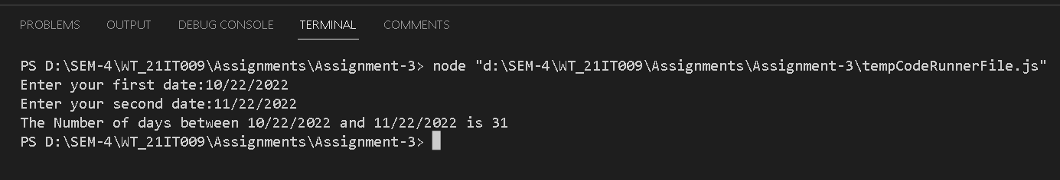

**Conclusion:-**

From this practical, I learned how to create an object in JS and how to count the number of days between two dates using the objects.